Occupancy in person board work.

Start here- draw black solid line. Explain
Then what happens when consistent under detection at all levels of habitat covariate….draw red line.
Then what happens when detection increasingly is worse at higher levels of covariate values- draw blue dashed line.

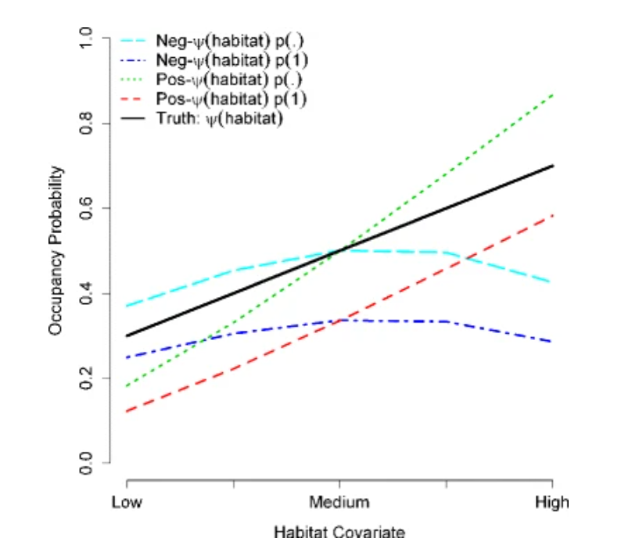

Draw model statement for logistic regression
y_i ~ Bernoulli (p_i)
logit(p_i) = X beta

draw vector of data. What could we get to help us separate out the detection an occupancy information. Replicates! Add more information showing under detection. Point at the information

Then draw model.
Y_ij ~ Bernoulli (z_i * p_i) ; observation/data process
Z_i ~ bernoulli(psi_i) ; process model
People say this is a hierarchical model. But nothing really shows it that way in this notation.
A hierarchical model conditions on some part of the model, specifically unobserved quantities. Notice that there is an unknown on the left side of the equation. This is a clue that it is hierarchical. But yet, we could make this more explicit,
[y_ij|z_i]~ Bernoulli (p_i* z_i)
Y_ij ~ { 0, z_i = 0
P_i, z_i = 1
}
z_i ~ Bernoullli

